

**American International University- Bangladesh**

**CSC 3215: Web Technologies**

**CO2 and CO4 Evaluation**

**Finished Project Report**

**Spring/Summer/Fall 2021-2022**

**Project Title: Here Fire Risk Management Website**

**Section: G**

**Group: 1**

|  |  |
| --- | --- |
| Student Name | Student Id |
| Tafiquzzaman, Md | 18-36743-1 |
| Saha, Apurbajyoti | 20-42423-1 |
| Kakon, Khairul Islam | 20-42438-1 |
| Ahmed, Wasif | 20-44137-2 |
| Haque, Md. Rakibul | 18-36117-1 |

**Project Description:**

We had declared 5 types of users in our project these are 1. Admin, 2. Stuff, 3. Medi Team, 4. Fund Raiser 5. General User. As an admin, we had chosen to verify user accounts,

update the site and check rules and regulations. Then we have featured the general user who can register on our site, they can donate to fire victims, and can also work as a volunteer.

For the medi team, we had given them access to managing blood and medicine and also for more volunteers. For the fund team, their job is to distribute the fund among fire victims

and raise more funds. For Stuff, they can register and also they can communicate with each other and they can share work updates.

**Project Folder Structure:**

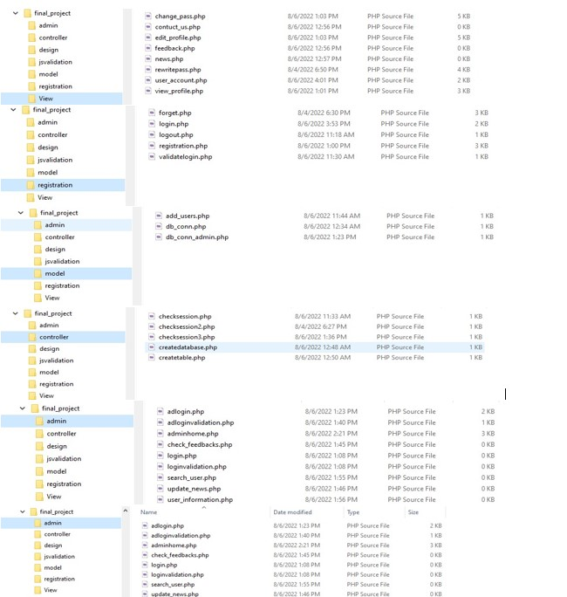

**Core Modules of the Project:**

***login.php***

*<!DOCTYPE html>*

*<html>*

*<head>*

*<title>Login</title>*

*<link rel = "stylesheet" href= "../design/design.css" />*

*</head>*

*<body >*

*<nav>*

*<div>*

*<p style = "font-size:40px; font-family:Arial;margin-bottom: 0px;margin-top:3px">LOG IN</p><br><br>*

*<div style ="margin-top: 0px; position: absolute;right: 80px;top:55px;text-decoration: none;border-style: solid;border-width: 1.5px; border-color: red;">*

*<a href="../registration/registration.php"><b style = "color:white;font-size:25px; font-family:Arial;"> SIGN UP here</b></a>*

*</div>*

*<div class = "nav1">*

*<a class="active" href="../index.php">Home</a>*

*<a href="../view/news.php">News</a>*

*<a href="./view/feedback.php">Feedback</a>*

*<a href="./view/contact_us.php">About Us</a>*

*</div >*

*</nav>*

*<div class="reg">*

*<form name = "logform" onsubmit = "return validateForm();" method="post" action="validatelogin.php">*

*<label>User Name</label>*

*<input type="text" name="user_name" id = "user_name" ><span style= "color:red" id = "alert2"></span>*

*<br><br><hr>*

*<label>Password</label>*

*<input type="text" name="password" id = "password" ><span style= "color:red" id = "alert4"></span>*

*<br><br><hr>*

*<input type="checkbox" name="remember_me" value="remembered">Remember me <a href="forget.php">Forgot Password?</a><br><br>*

*<input type="submit" name="submit" value="login">*

*<?php if (isset($_GET['error'])) { ?>*

*<p class="error" style="color:red; font-size: 100%; font-weight: bold;"><?php echo $_GET['error']; ?></p><?php }?>*

*</form>*

*</div>*

*<footer class="regf">*

*All rights reserved. &copy 2022 <br>*

*</footer>*

*<script src="../jsvalidation/login.js"></script>*

*</body>*

*</html>*

***Index.php***

*<html lang="en">*

*<head>*

*<meta charset="UTF-8">*

*<meta http-equiv="X-UA-Compatible" content="IE=edge">*

*<meta name="viewport" content="width=device-width, initial-scale=1.0">*

*<title>Homepage</title>*

*<link rel = "stylesheet" href= "design/design.css" />*

*</head>*

*<body>*

*<nav>*

*<div>*

*<p style = "font-size:40px; font-family:Arial;margin-bottom: 0px;">Fire Risk Management</p>*

*<br><span style = " color:white; font-weight: bold;">Help us to prevent unnecessary Fire</span>*

*<div style ="margin-top: 0px; position: absolute;right: 80px;top:55px;text-decoration: none;border-style: solid;border-width: 1.5px; border-color: red;">*

*<a href="registration/login.php"><b style = "color:white;text-decoration: none;font-size:25px; font-family:Arial;"> LOGIN |</b></a>*

*<a href="registration/registration.php"><b style ="color:white;text-decoration: none;font-size:15px; font-family:Arial;"> SIGN UP</b></a>*

*</div>*

*<div class = "nav1">*

*<a class="active" href="#home">Home</a>*

*<a href="view/news.php">News</a>*

*<a href="view/feedback.php">Feedback</a>*

*<a href="view/contact_us.php">About Us</a>*

*</div>*

*</nav>*

*<div class="nav2">*

*<ol class="nav2a" >*

*<a href="#news" style ="color:red; text-decoration: none;">Donation </a><br><br><br><br><br><hr><br><br><br><br>*

*<a href="#contact" style ="color:red; text-decoration: none;">Medical contribution</a>*

*</ol>*

*</div>*

*<div class= "nav3">*

*"The measure of a life, after all, is not its duration, <br>but its donation." <br><br><br><p style="background-color:rgb(0, 255, 13);margin-right:425px;border-radius:12px"> Donate Now!</p>*

*</div>*

*<div class="nav4">“The art of medicine consists of amusing the patient while nature cures the disease.”*

*<br><br><br><p style="background-color:rgb(0, 255, 13);margin-right:500px;border-radius:12px"> help!</p></div>*

*</div>*

*<footer>*

*All rights reserved. &copy 2022 <a href="admin/adlogin.php"style="text-decoration:none;"><p style="color:black;">ADMIN</p></a><br>*

*</footer>*

*</body>*

*</html>*

***User_account.php***

*<?php include '../controller/checksession.php';?>*

*<!DOCTYPE html>*

*<html>*

*<head>*

*<title>User_Account</title>*

*<link rel = "stylesheet" href= "../design/design.css" />*

*</head>*

*<body >*

*<nav>*

*<div>*

*<p style = "font-size:40px; font-family:Arial;margin-bottom: 0px;margin-top:3px">Dashboard</p><br><br>*

*<div style ="margin-top: 0px; position: absolute;right: 80px;top:55px;text-decoration: none;border-style: solid;border-width: 1.5px; border-color: red;">*

*<a href=><b style = "color:white;font-size:25px; font-family:Arial;">*

*<?php*

*if(isset($_SESSION['user'])){*

*echo "Welcome ".$_SESSION['user'];*

*}?> </b></a>*

*</div>*

*<div class = "nav1">*

*<a class="active" href="index.php">Home</a>*

*<a href="../view/news.php">News</a>*

*<a href="./view/feedback.php">Feedback</a>*

*<a href="./view/contact_us.php">About Us</a>*

*</div >*

*</nav>*

*<ul class="reg" >*

*<ol><a href="view_profile.php" style= "text-decoration: none;font-size:20px; font-weight:bolder;">View Profile</a></ol>*

*<br><br>*

*<ol><a href="edit_profile.php" style= "text-decoration: none;font-size:20px; font-weight:bolder;">Edit Profile</a></ol>*

*<br><br>*

*<ol><a href="change_pass.php" style= "text-decoration: none;font-size:20px; font-weight:bolder;">Change Password</a></ol><br>*

*</ul>*

*<div class="ui">*

*<form method="POST" action="../registration/logout.php">*

*<button type="submit" name="logout_btn">Log out</button>*

*</form>*

*</div>*

*<footer class="regf">*

*All rights reserved. &copy 2022 <br>*

*</footer>*

*</body>*

*</html>*

|  |  |  |  |  |  |
| --- | --- | --- | --- | --- | --- |
| **CO2 and CO4 Evaluation: Project Report Evaluation** | | | | | |
| **Completeness**  **(5)** | **Validation**  **(5)** | **Feature Implementation**  **(5)** | **Concept Understanding**  **(5)** | **Promptness (5)** | **Total (25)** |
|  |  |  |  |  |  |
|  | | | | | |